**Capstone Project Proposal**

Project #19: Improved AUV

Metron Inc. and PSU NEAR Lab

*Adam Provost*

*Jinhao Hou*

*Yuhang Zhu*

*Noah Page*

**(Rev 1.5)**

**2 / 6 / 2021**

**Overview/ Executive Summary:**

Our capstone team’s purpose is to further improve the navigational abilities of NEAR Lab’s Riptide Systems model 1-MP Unmanned Underwater Vehicle by sourcing a echo sounder sonar transducer that will allow for object detection and active collision avoidance. We will be building upon the work of previous capstone teams in order to meet the goal of assisting the Maritime Archaeological Society (MAS) in finding the “Beeswax Wreck”. For the past 15 years the Beeswax Wreck Project has been searching for a Spanish galleon that wrecked on the Oregon coast in 1693. The expected location of the galleon is very difficult for boats and divers to access so an autonomous underwater vehicle (AUV) has been selected as an ideal candidate to assist in mapping the seafloor and finding the wreckage site.

Although last year’s capstone teams were successful in implementing many improvements, the AUV unfortunately had a nose cone defect that caused it to leak. Since the parent company Riptide Systems has since been acquired by BAE Systems they are unable to source a replacement, and so the task of developing a nose cone replacement has been given to a Portland State University mechanical engineering capstone team. With the creation of a new nose cone came the opportunity to improve the AUV by adding a forward looking sonar system that allows for object detection and active collision avoidance. So this year Metron Inc. has sponsored an interdisciplinary capstone team of aspiring computer, electrical, and mechanical engineers to develop and test said nose cone for the AUV.

**Product Design Specification:**

**Concept of Operations:**

Our project is to improve an existing autonomous underwater vehicle’s (AUV) navigation by adding active collision avoidance hardware and software. Our sponsors Metron Inc and PSU NEAR Lab plan to use the AUV for acoustics research and in the search for historical shipwrecks in conjunction with the Maritime Archaeological Society. We are working in an interdisciplinary team of MEs and ECEs since our choice in sensor must be compatible with a new nose cone developed by the ME team.

**Requirements & Specifications:**

* ***Must:*** 
  + Research and select an appropriate echosounder
    - Price Must be less than $1000
  + Create a test plan per projected requirements
  + Have a proof of concept/preliminary test of the selected echosounder
* ***Should:***
  + Be compatible with ME’s design choices
  + Integrate with MOOS IVP
* ***May:*** 
  + Develop a collision avoidance program
  + Test collision avoidance in AUV

**Stakeholders:**

* Metron Inc.
* PSU NEAR Lab
* Maritime Archaeological Society

**ECE Deliverables:**

❖ Detailed design documentation (initial research, decision matrix, API, etc.)

❖ Weekly progress reports in the form of related work being uploaded Google Drive

❖ A final report that displays our research, findings, and recommendations

❖ A Capstone Poster Session poster for the capstone project required presentation

❖ A BOM (Bill of Materials)

* Must:
  + Test plan for isolated echosounder
  + Proof of concept demonstration of echosounder’s ability for object detection
* Should:
  + Documentation of compatibility
* May:
  + Collision avoidance test plan for AUV in pool

**Initial Product Design:**

Our team needs to identify potential echosounders that fit our requirements on size, beam pattern, frequency, range, and price. Of these requirements, price is the only one that is set since our budget is $1000. We have a general idea of what the dimensions of the transducer can be based on the diameter of the UAV, however, the ME team will be providing feedback as they will be designing the nose cone to fit around the selected device. We need to further research the turning capabilities of the UAV at both max speed and typical speed to determine the ideal range of the echosounder. The angle of the beam pattern is also an important consideration in obstacle detection and the frequency must be able to penetrate the nose cone and work well in salt water, however, our budget is a limiting factor in this decision since most of the sensors identified thus far exceed our price range. Once we have a list of candidates we will create a decision matrix and present our findings to the mechanical team and our sponsor. Then when the selected echosounder has arrived we will begin testing it to verify that it meets our requirements. Finally, we will integrate it with the AUV’s electronics and develop the active obstacle avoidance software using MOOS-IVP.

❖ Hardware Architecture

➢ Riptide 1MP stock hardware architecture from the User Manual

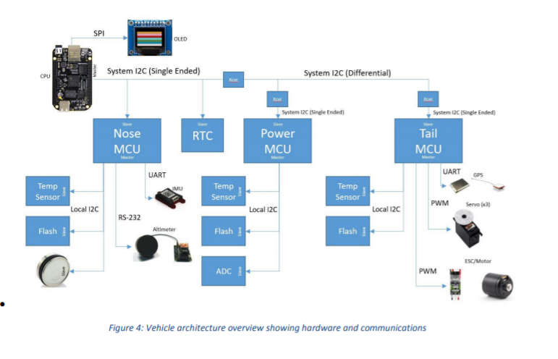

Our hardware architecture will be a slight variation of the stock setup seen above, where our echosounder will have a similar role as the altimeter since our current list of candidates use either the RS-232 or RS-485 serial interface and will also be positioned in the nose cone.

❖Software Architecture

➢ MOOS IVP autonomous control software (C++)

➢ Beaglebone Black Linux environment (Debian)

❖ Back up plans

➢ Ultimate goal is autonomous collision avoidance program, however, we may limit scope to the “musts” of providing proof of concept test to prove the viability of our echosounder selection

**Project Management Plan:**

**Timeline:**

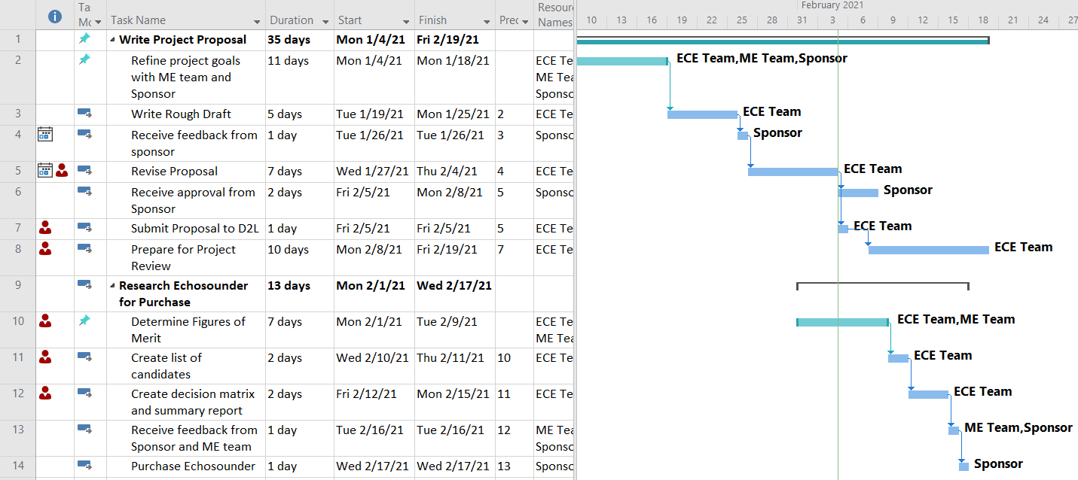

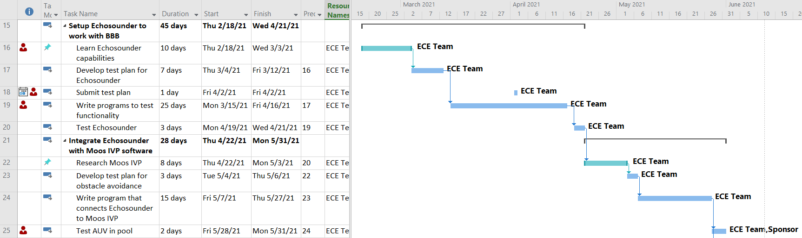

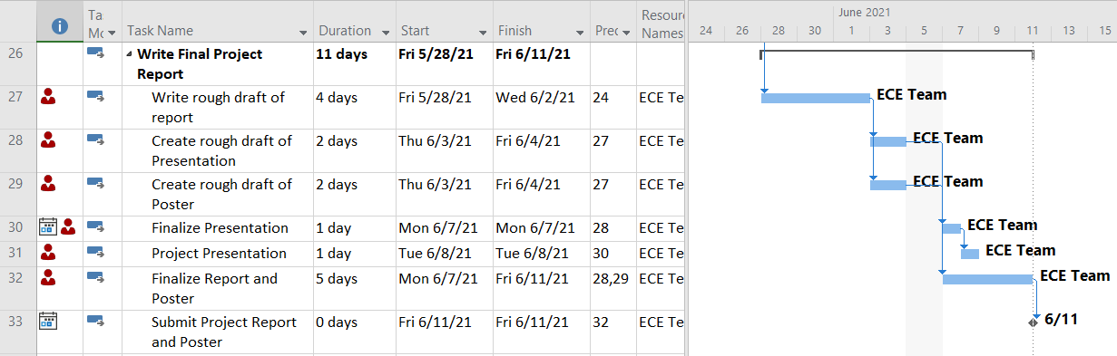

**Milestones:**

* Define requirements for sensor based on AUV’s capabilities and ME team’s design decisions
* Conduct research on echosounder candidates
* Generate necessary documentation of results to receive approval of final decision
* Order Echosounder
* Test Echosounder’s object detection in relevant environment
* Generate test cases for AUV such that it can receive environmental input and respond according within the range of the AUV’s capabilities
* Integrate Echosounder with Moos IVP to create collision avoidance program
* Test AUV’s collision avoidance in pool
* Create Final Project Report and Presentation

**Budget:**

❖ A BOM (Bill Of Materials) should be devised such that all components, manufacturing, and costs are enumerated and documented

❖ Echosounder budget approximately $1000

❖ All purchases shall be thoroughly researched and decided upon as a team

❖ All purchases shall be approved by the sponsor and sponsoring organization

❖ Budget constraints shall be discussed with sponsor as the project progresses on a need be basis

**Team and Development Process:**

❖ Team members: Adam Provost, Yuhang Zhu, Noah Page, Jinhao Hou.

❖ Skills: Matlab, Circuit design, Basic electronics, Signals and systems controls.

❖ The point person to be communicating with the industry sponsor and the faculty advisor is Adam Provost, who is our ECE team leader.

❖ We will use the GitHub collaboration website.

❖ We will follow the timeline. We want to try to learn something from this project. We strive to make the project successful.